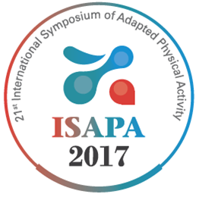
ISAPA2017
21st International Symposium of Adapted Physical Activity
June 12~16, Daegu, Korea
WWW.isapa2017.com

Application Form for ISAPA2017 Travel Grant
Personal information
Title |  | Email
First name |  | Last name
Address |  | State
Mobile |  | Age
University |  | Faculty

Have you taken part in an ISAPA before?
If so, where ___________________

I will announce the following abstracts for the ISAPA2017.

-----------------------------------------------------------------------------------------------------------------------------------------------
The travel grant will be offered to outstanding abstract submitter - students, fellows, early career professionals and may vary depending on the ISAPA 2017 financial situation. It will be given in cash at the symposium site(Closing Ceremony).
To be sent to
Prof.Dr. Sok-Rok Song, Organizing Committee for ISAPA2017 by email to disportare@hanmail.net

Incomplete applications will not be accepted.
Funding Information
Have you ever received a ISAPA travel grant before : Yes / No
If yes, please When? _______________________________________:

Did you receive Funding from any other source?
If yes, please specify:
Source | Amount

Personal Statement
In 300 words or less, please give a brief description of your presentation and explain the importance of ISAPA2017 to your academic career:

_________________________________________________________________________________________________

The Organizing Committee for the 2017 International Symposium of Adapted Physical Activity
--------------------------------------------------------------------------------------------------------------------
The Organizing Committee for the 2017 International Symposium of Adapted Physical Activity
Tel.: +82 53 810 3548
isapa2017@gmail.com
Address : Office Nr. 256, 280 Daehak-ro Gyeongsan-si, Gyeongsangbuk-do, South

